## Step 1

Set up Bitbucket

## Step 2

Import repo from <https://katrinhartmann@bitbucket.org/katrinhartmann/wpd2_lab1.git>

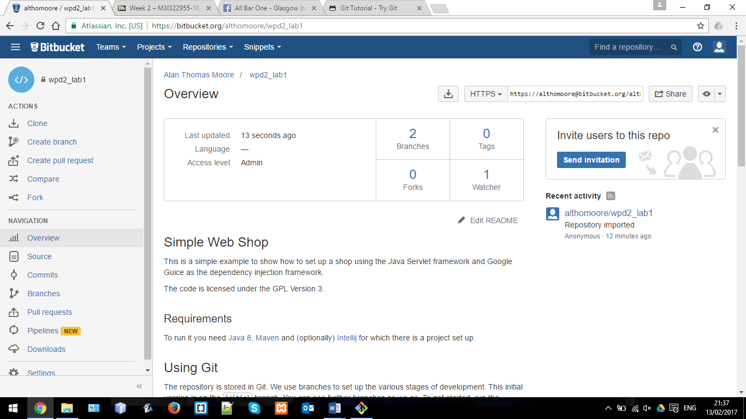

## Step 3

Open Gitbash

## Step 4

Clone repo from <https://althomoore@bitbucket.org/althomoore/wpd2_lab1.git> onto local drive

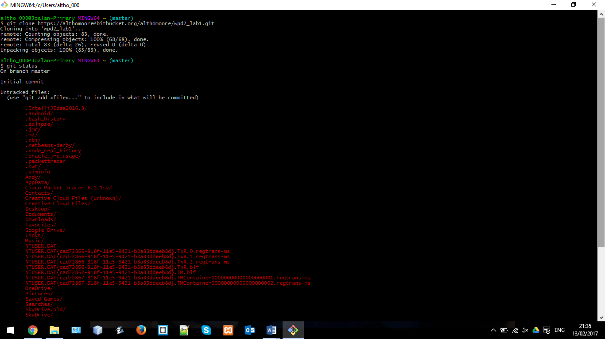

## Step 5

Change directory: cd wpd2_lab1

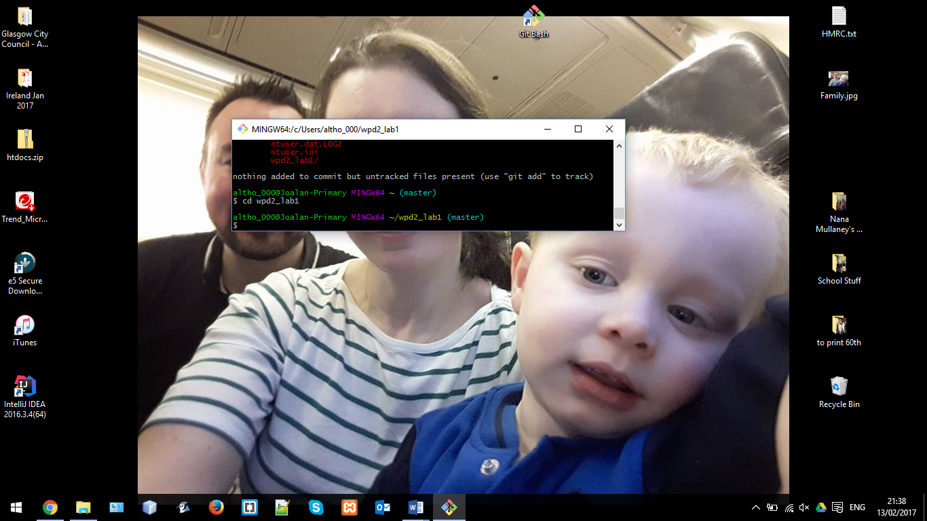

## Step 6

Initialise git: $git init

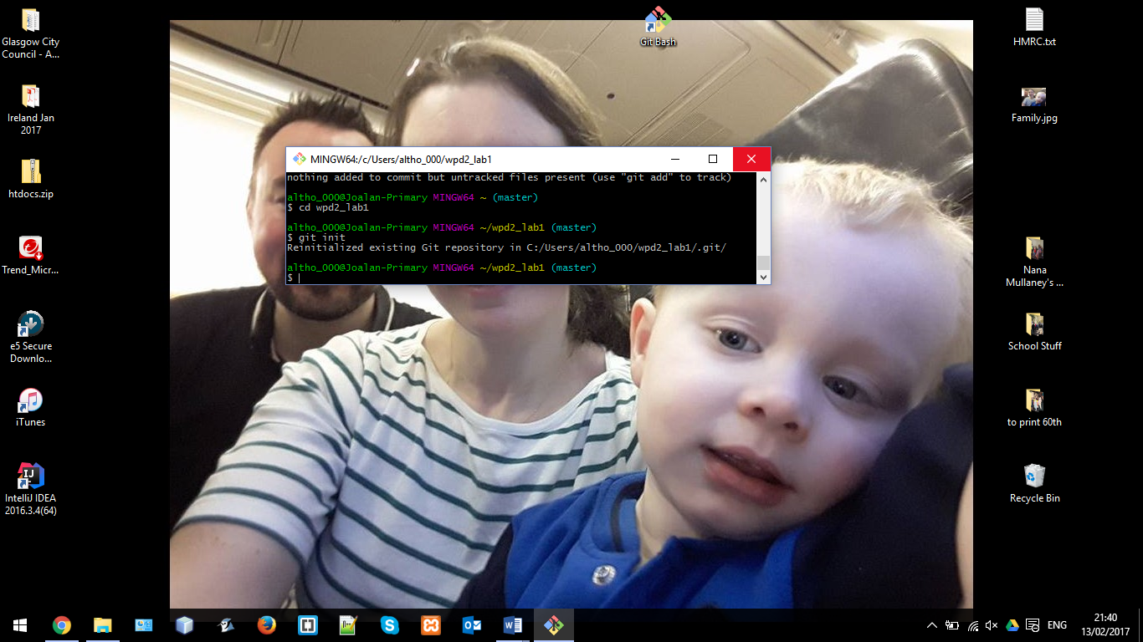

## Step 7

Check status: $git status

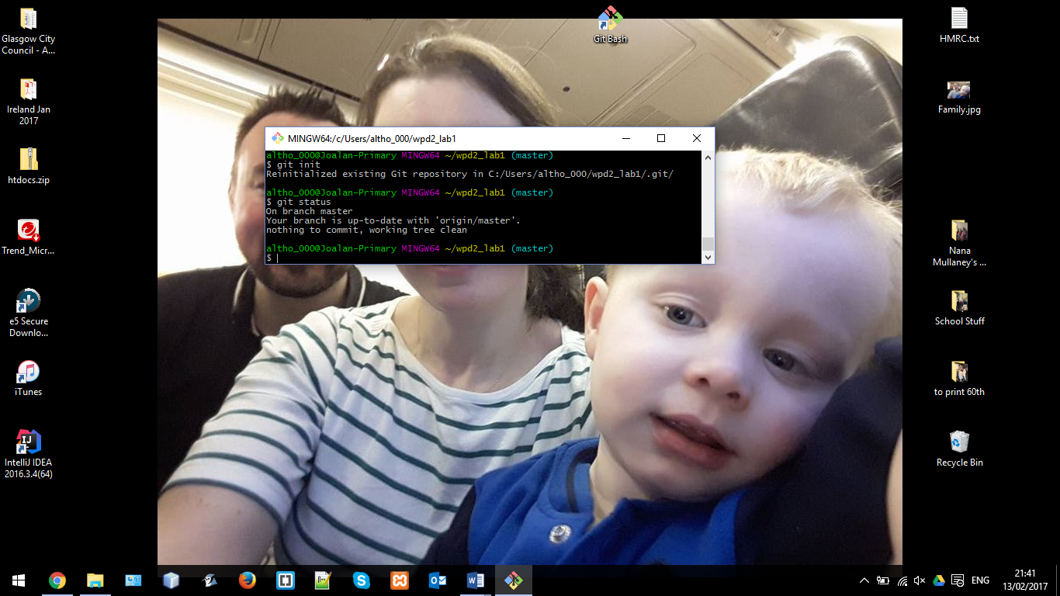

## Step 8

Start IntelliJ and import project from wpd2_lab1

## Step 9

Run runner file

## Step 10

Open index.html

## Step 11

Go to browser and input localhost:9000 in address bar

## Step 12

Make all the changes needed in IntelliJ:

* Add Javascript file
* Add CSS file
* Add folder for images
* Add code to each file to change the HTML

## Step 13

Check the status in Gitbash: $git status

## Step 14

Add everything that has changed to the repository: $git add .

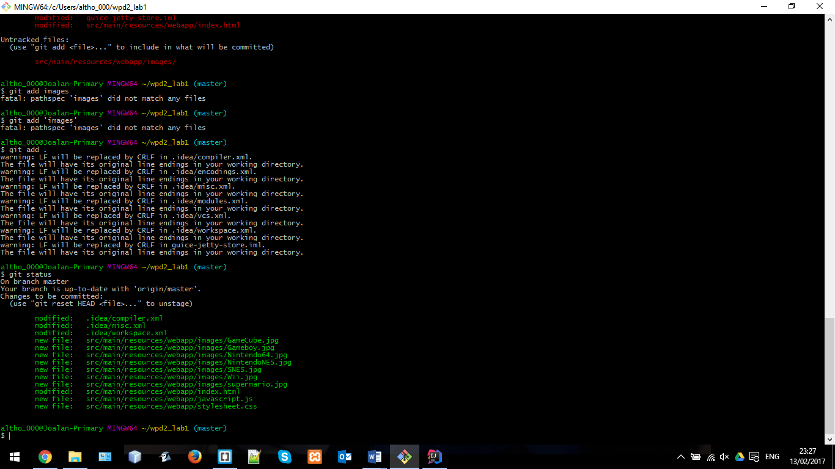

## Step 15

Check the status again: $git status

Step 16

Commit the changes to the repository: $git commit -m “First Draught”

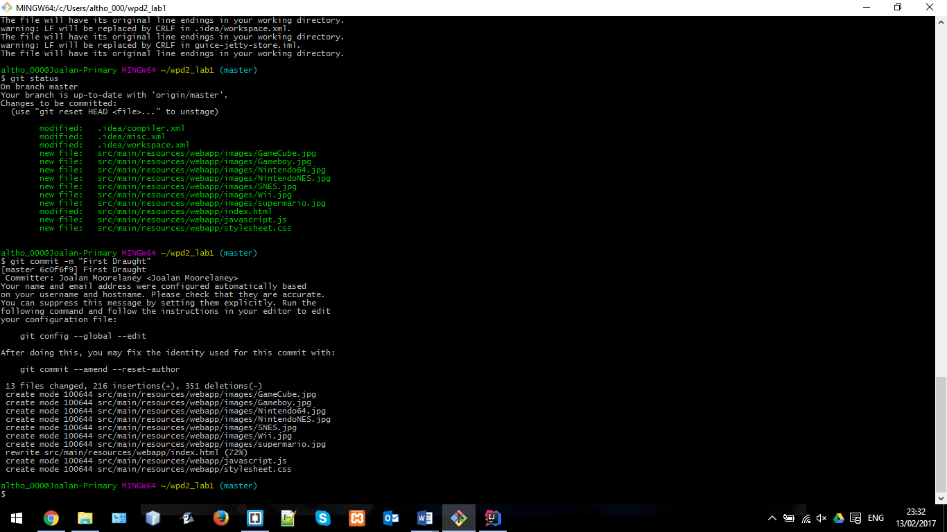

## Step 17

Check the logs: $git log

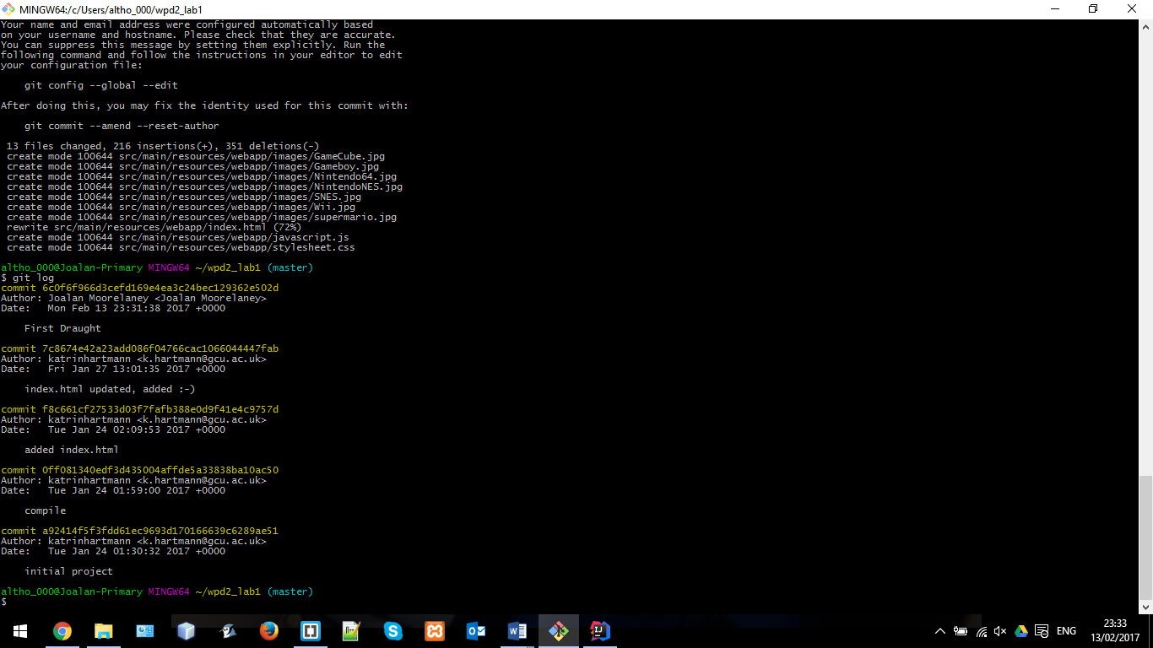

## Step 18

Check the remote origin: $git remote -v

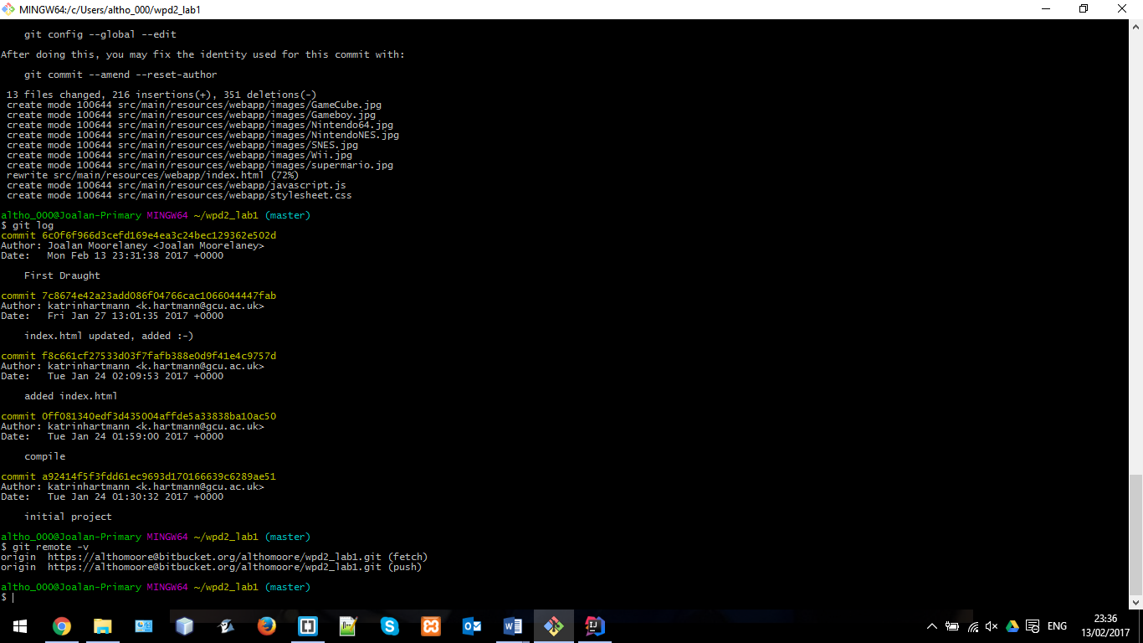

## Step 19

Push everything into the remote origin master file: $git push -u origin master

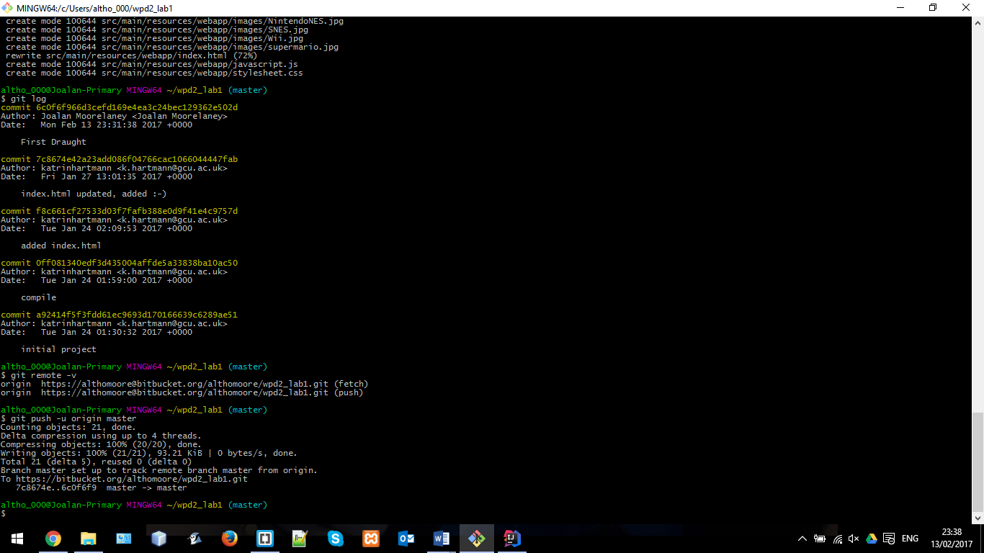

## Step 20

Check Origin Master for changes

SUCCESS